Jennifer Chung ([jrc98@njit.edu](mailto:jrc98@njit.edu))

### Homework #5 - Web Forms with Flask, Docker, PyCharm, and MySQL

1. GitHub Repository –

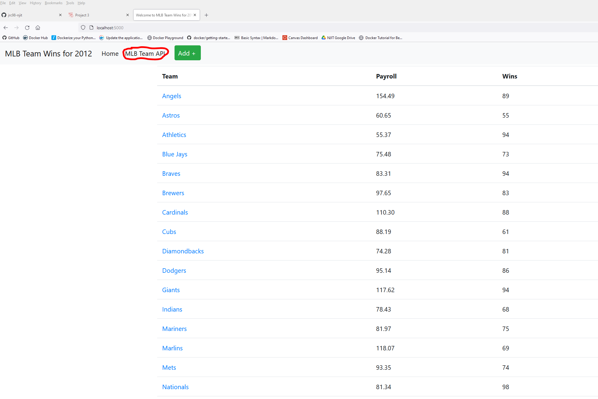

2. Submit a word document with screen shots of the following:

1. The project showing postman listing all records

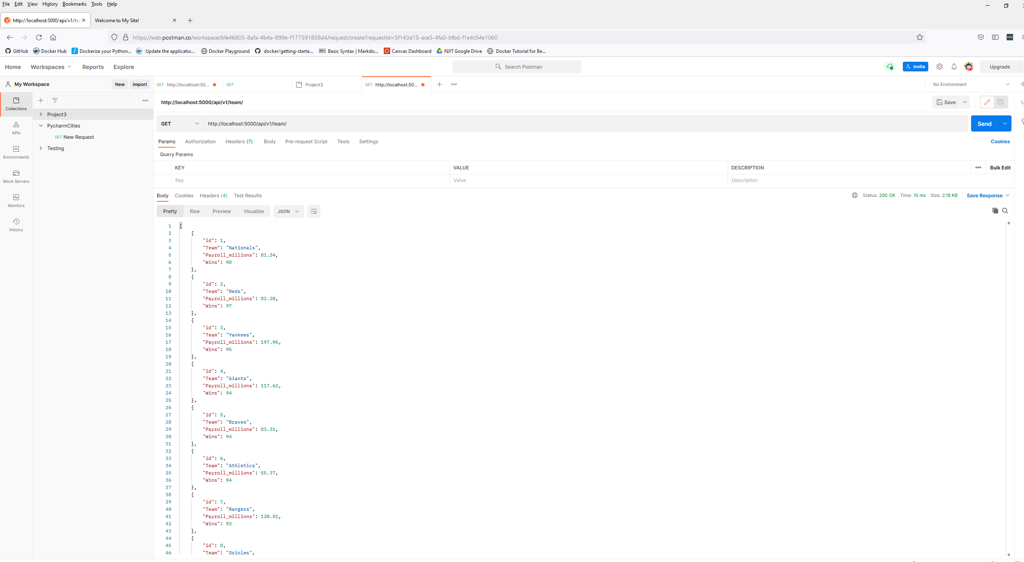

1. The project showing postman showing one record with a get request

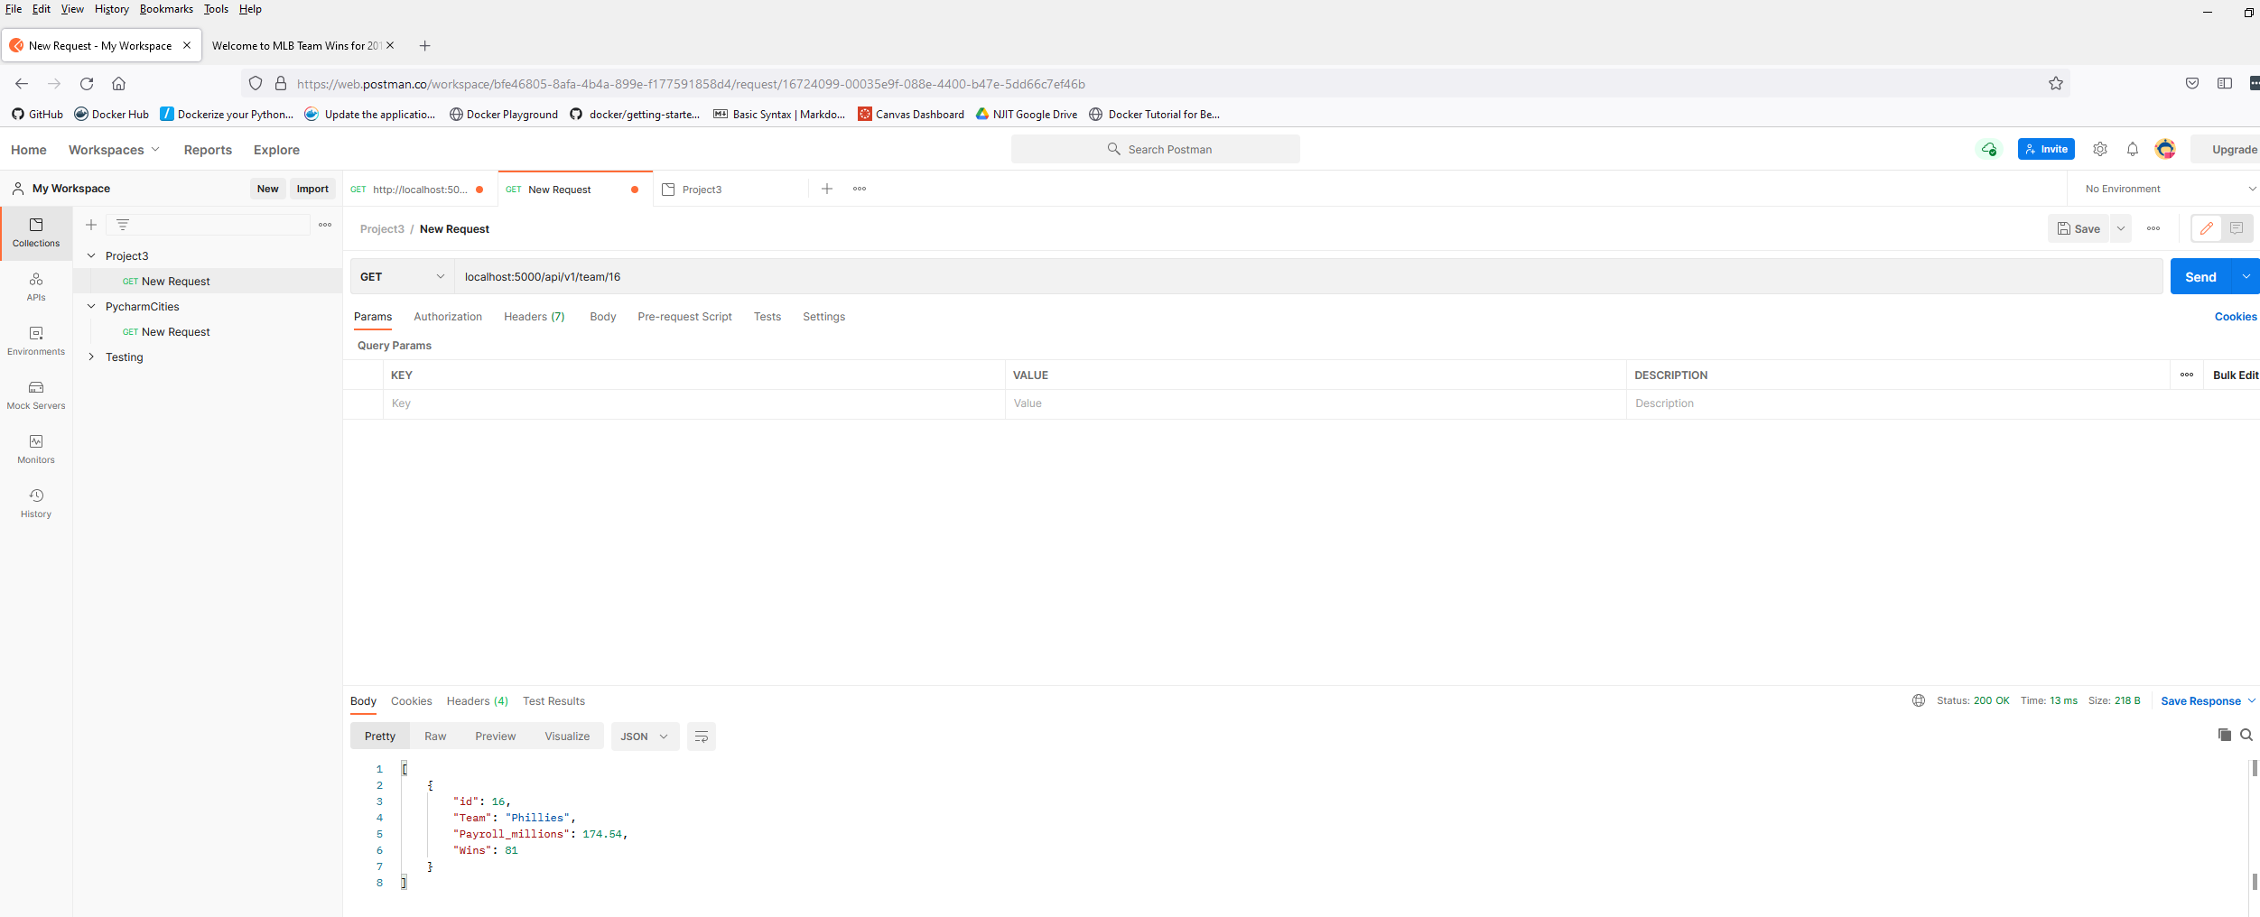

1. The project showing postman creating a record by showing the post request and the results in the record listing

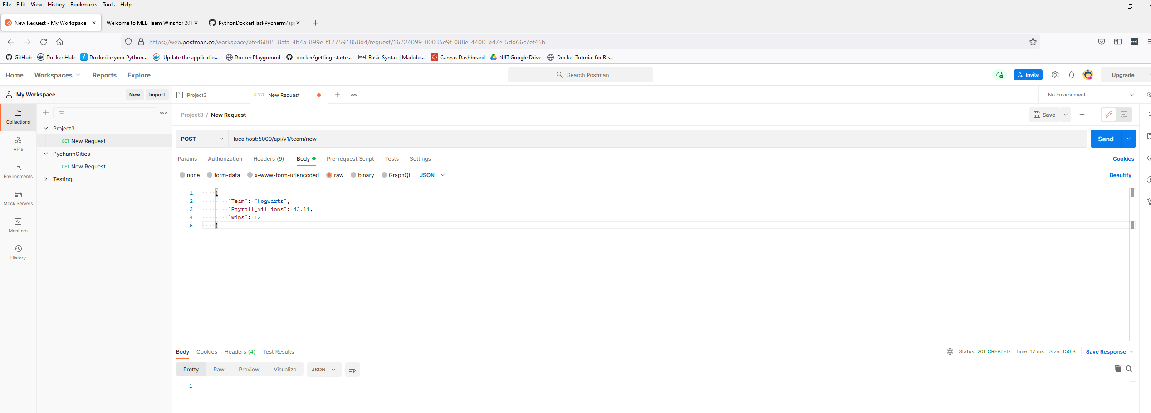

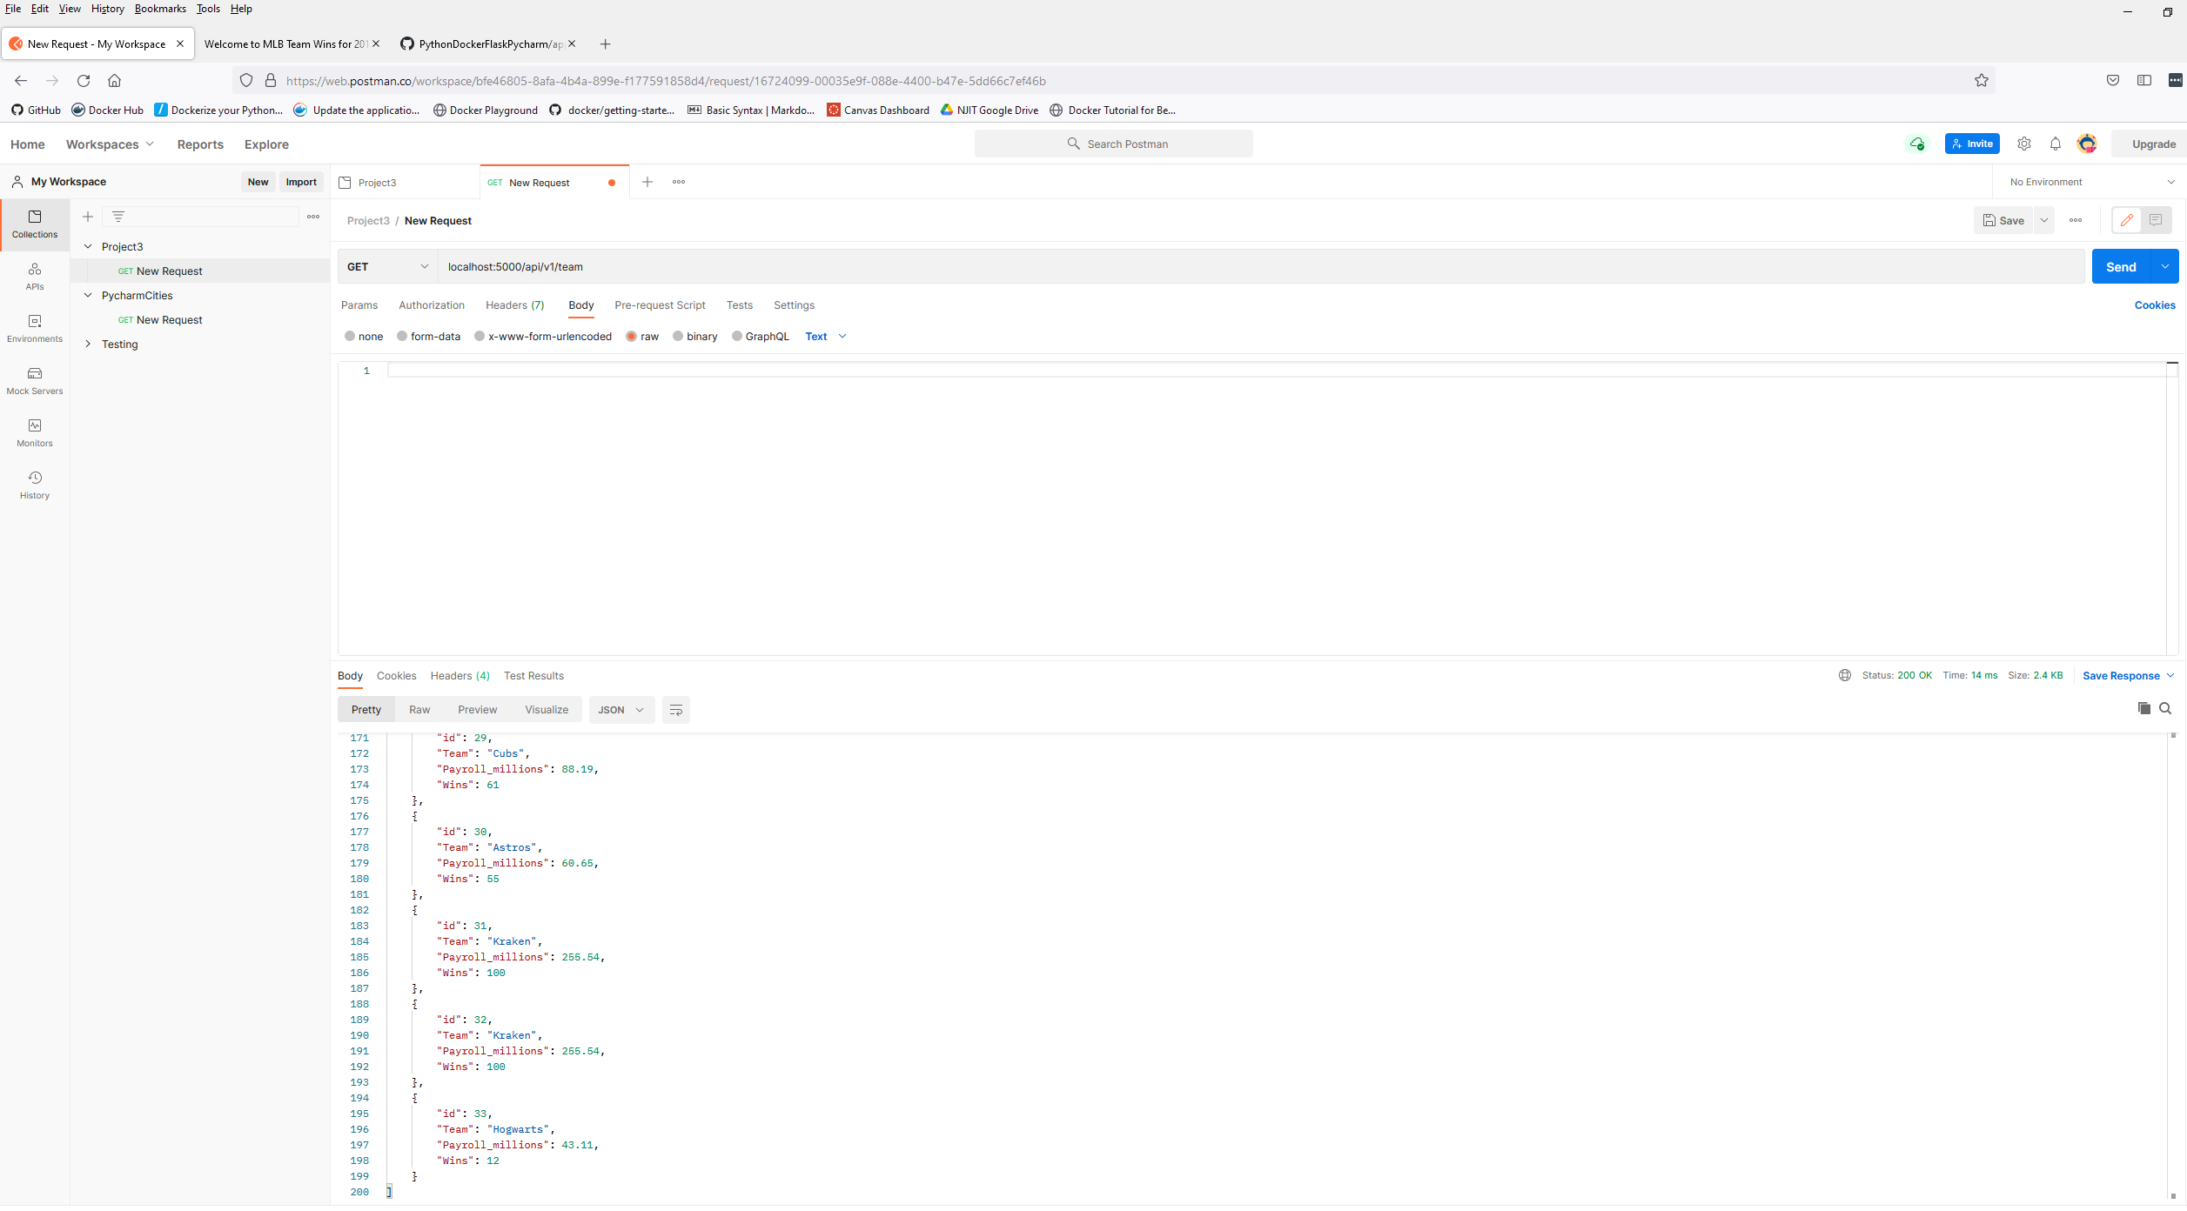

1. The project showing postman edit a record by showing the put request and the results in the record listing

Before the Edit (Put Request) – Phillies Data

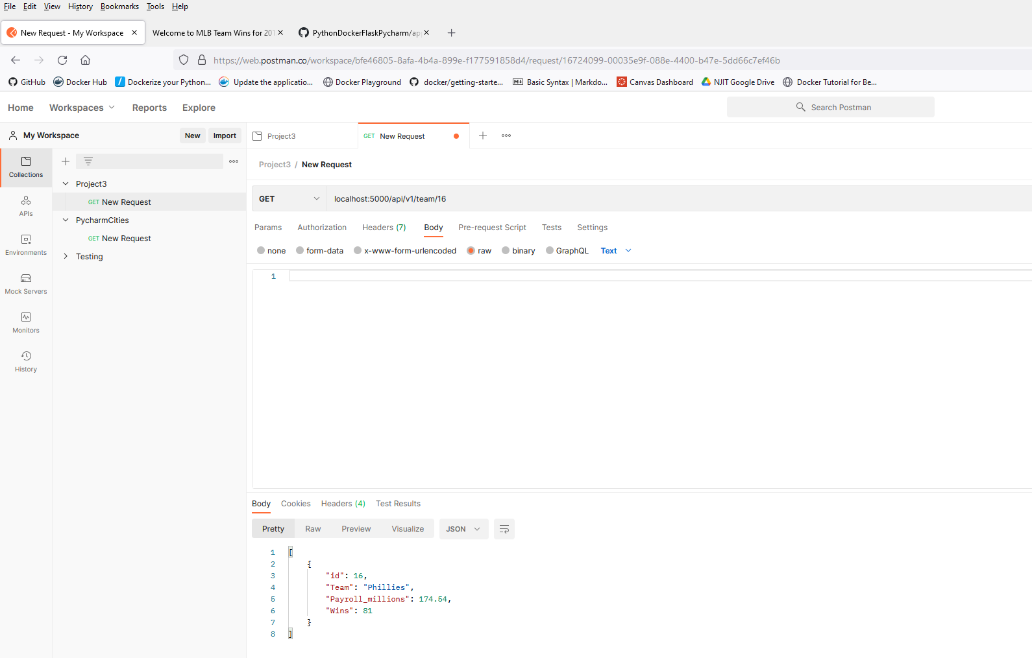

Put Request) – Phillies Data (change Wins to 240)

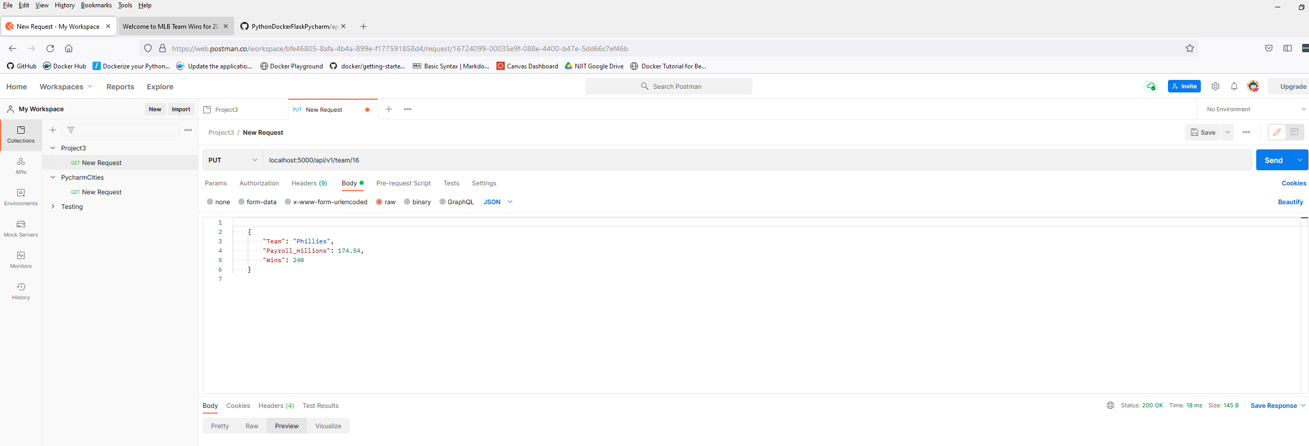

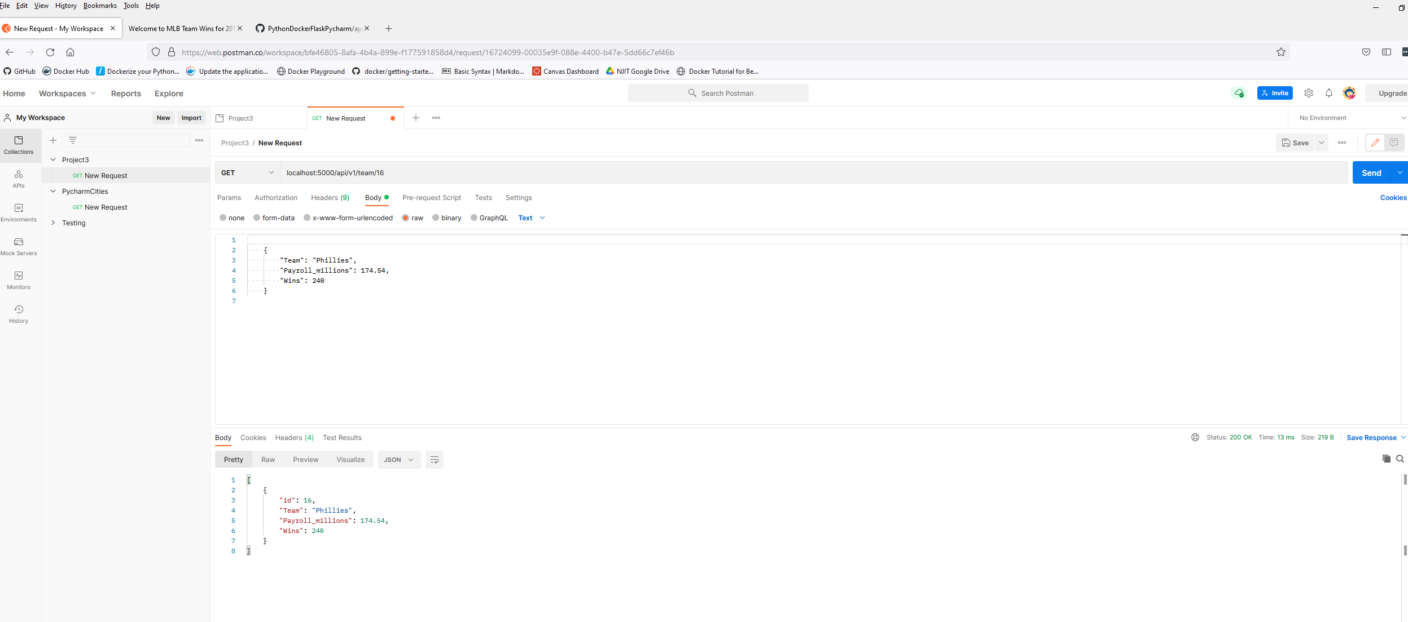

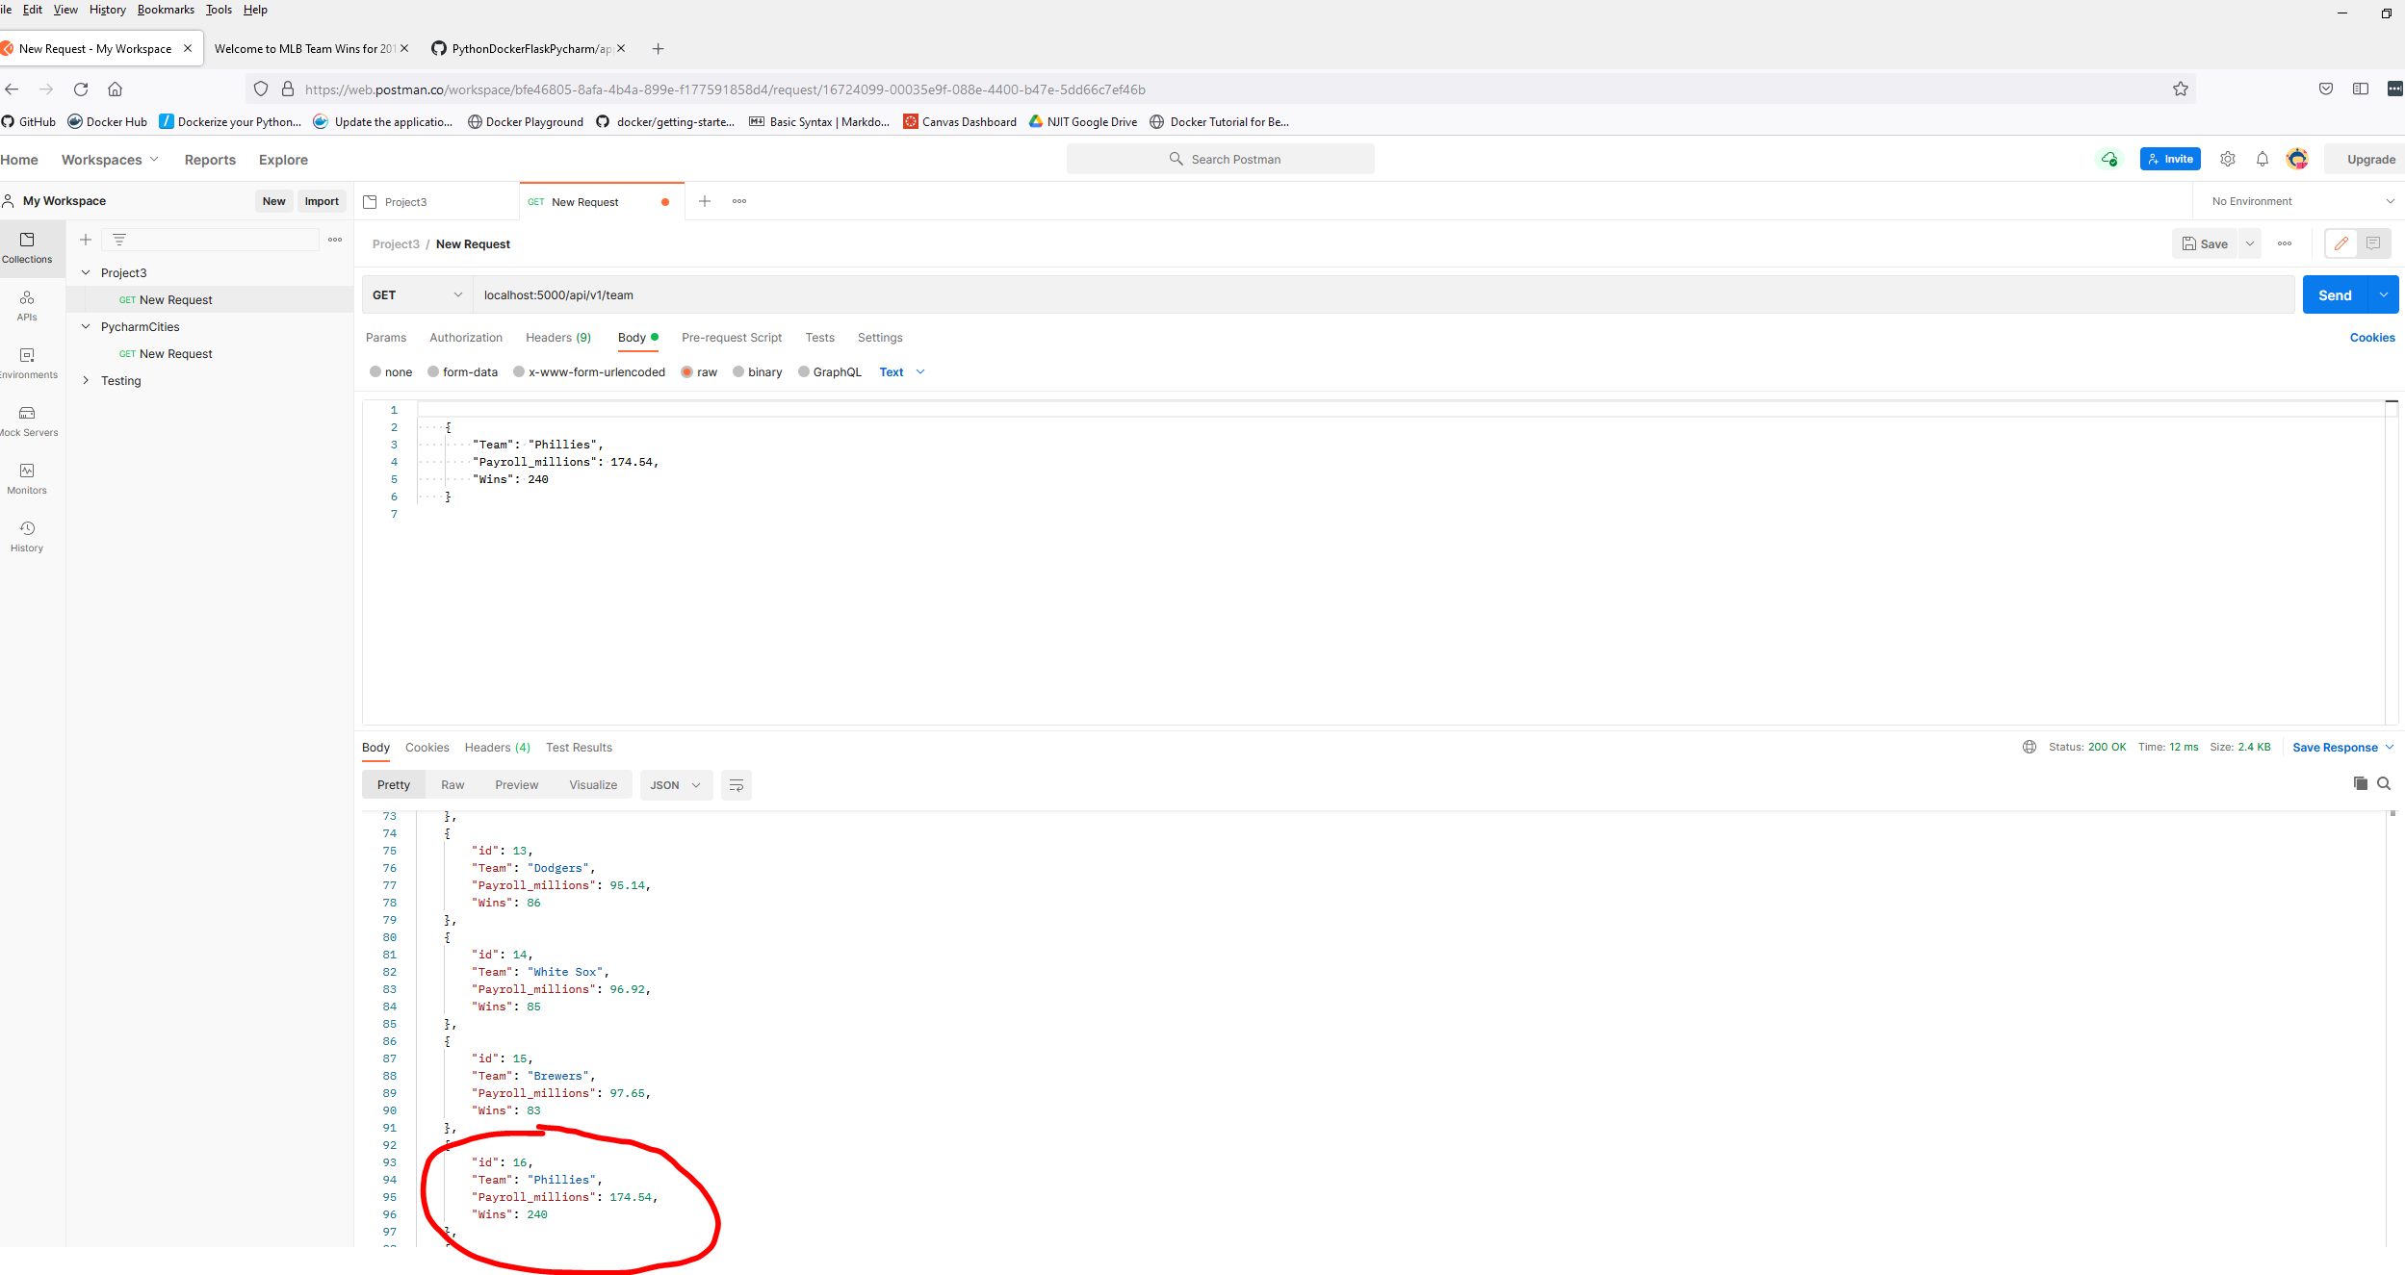

1. The project showing postman delete a record by showing the delete request andv the results in the record listing.

Before – I have two Kraken teams (#31, #32) I will remove #32.

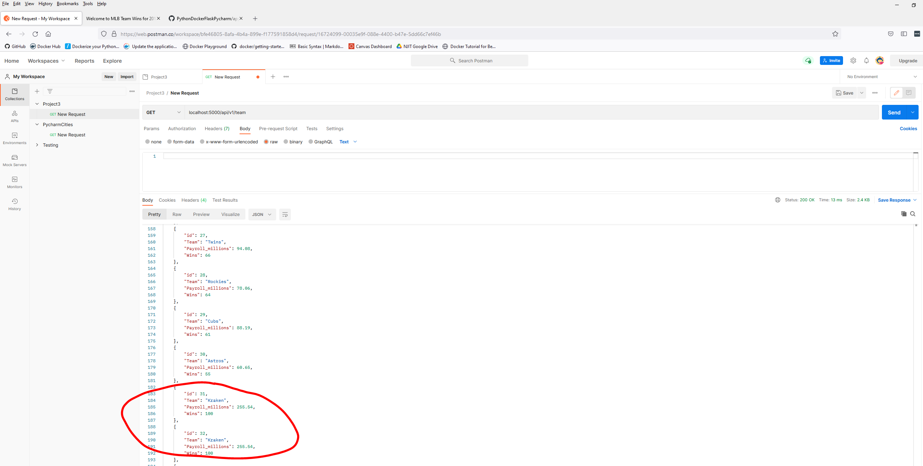

#32 – Delete Request

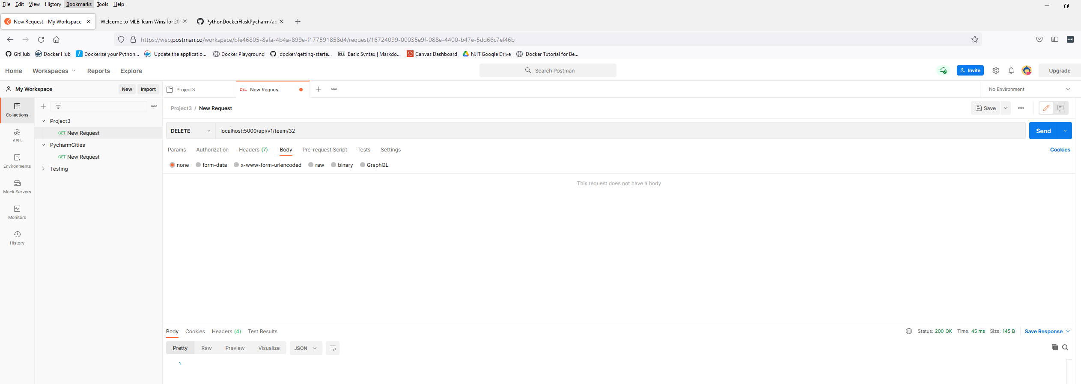

#32 is gone

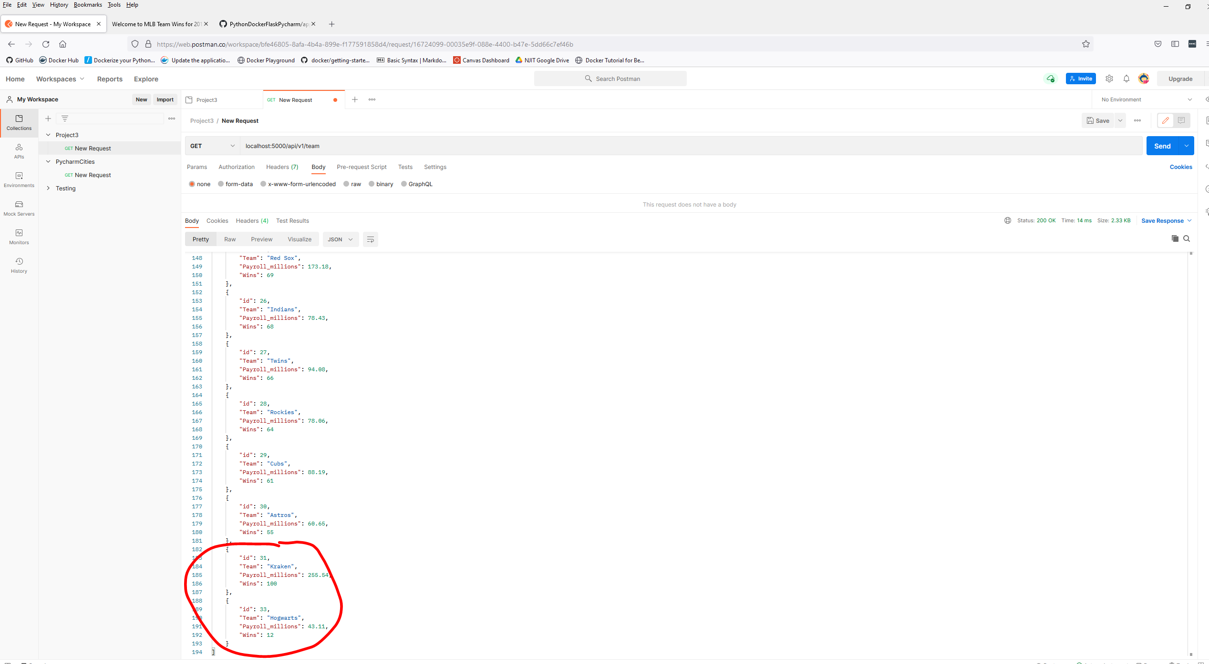

Final Homepage

* Phillies – Edit on wins (81 changed to 240)
* Hogwarts – New/Add
* Kraken – Delete #32

